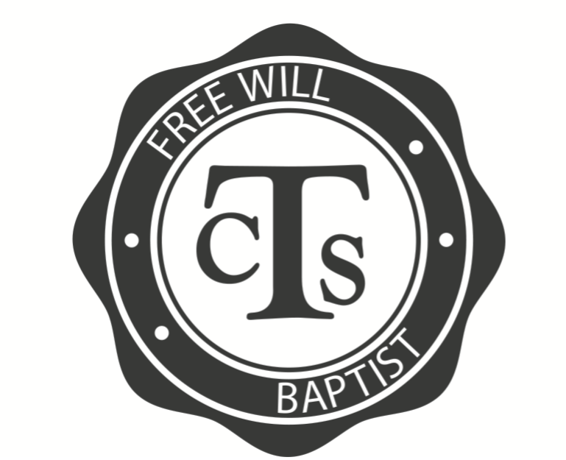
Parent/Guardian Name:
CTS
Interest
Form

E-mail Address: _________________________ Phone Number:
Would you be interested in volunteering to help coach? Yes… Category #(s):

Child / Teen  NAME | GRADE  the  Spring before Competition | Individual  Memo  (Grades K5-12) | Group Memo  (Grades 1-12) | Millionaire  (Grades 4-6) | Sword Drill  (Grades 4-6) | Tic-Tac-Toe  (Grades 7-9) | Bible Bowl  (Grades 10-12) | TruthQuest  (Grades 7-8, 10-12) | Other | Preferred Practice Time | WED  before church | SUN before evening service | SUN after  evening service | Competition?
CTS stands for Church Training Service and is a national program that has existed among Free Will Baptists for more than 50 years. It is a tool for churches to help students develop a deeper knowledge of Scripture while also identifying and honing talents for use in the local church. Students select categories for development and then engage in a competition style exhibition at the local, state, and national level. We want to downplay the competitive nature of this program, though. It is designed to be a ministry development tool and should be used as part of an overall discipleship plan. For those interested in competing at the State and National levels, we encourage them to participate in at least one Bible category
Please circle any other areas of development/competition you may be interested in below:
Category 1 – Vocal Solo
1.10 – Grades K5 – 6th
1.20 – Male (Grades 7-12)
1.30 – Female (Grades 7-12)
Category 2 – Vocal Ensemble
2.20 – Duet
2.30 – Trio
2.40 – Quartet
2.50 – Ensemble (5-12 members)
2.60 – Choir (13 members or more)
Category 3 – Instrumental Solo
3.10 – Woodwinds
3.20 – Brass
3.30 – Bowed Strings
3.40 – Plucked Strings
3.50 – Pitched Percussion
Category 4 – Instrumental Ensemble
4.10 – Duet, Trio, or Quartet
4.20 – Five or more members
4.30 – Praise Band

Category 8 – Creative Writing
8.1x – Article (8.11, 8.12)
8.20 – Personal Experience Essay
8.30 – Book Review
8.40 – Interview
8.50 – Devotion
Category 9 – Digital Media
9.10 – Video Production
9.20 – Slideshow
Category X – Exhibition Events
X.10 – Preaching
X.20 – New Ministry Idea
X.SN – Special Needs

Competition Entry Fees (Church)
$15.00 per exhibition event
$30.00 per single entry category
$60.00 per group entry of 2-4 people
$100.00 per group entry of 5+ people

Need More Information?

NC State Youth Competition
ncyouthmin.org

National Youth Competition
nafwb.org

Let the words of my mouth and the meditation of my heart be acceptable in Your sight.
O Lord my strength,
and my redeemer.
Psalm 19:14
Category 5 – Keyboard
5.10 – Manual/Electronic Solo
5.20 – Keyboard Ensemble
Category 6 – Communication Arts
6.1x – Sign Language (6.11, 6.12)
6.20 – Christian Literature Recitation
6.30 – Illustrated Storytelling
6.40 – Human Video
6.5x – Drama (6.51, 6.52, 6.53)
6.6x 6– Puppetry (.61, 6.62)
Category 7 – Creative Arts
7.10 – Painting
7.20 – Drawing
7.30 – Mixed Media
7.4x – Computer Generated Art (7.41, 7.42, 7.43)
7.5x – Photography (7.51, 7.52)
7.6x – Textiles (7.61, 7.62, 7.63)
7.7x – Ceramics (7.71, 7.72)
7.80 – Conceptual Art

